**Experiment 22**

**AIM :**

To design DFA of even number of a’s in automata.

**Design and output:**

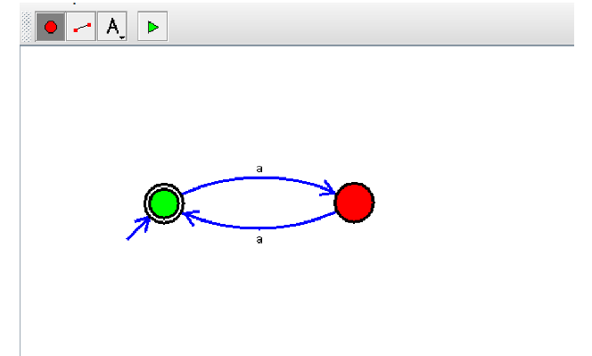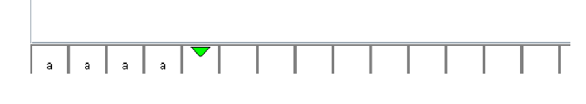

**Result:** Thus designing DFA of even number of a’s is done and verified by giving sample inputs.